Project Design Phase
Solution Architecture

Date | 3 October 2026
Team ID | SWTID-2026-4339
Project Name | Streamlining IT Procurement: Automating Standard Laptop Orders with Flow Designer
Maximum Marks | 4 Marks
Solution Architecture:
Solution architecture is a complex process – with many sub-processes – that bridges the gap between business problems and technology solutions. Its goals are to:
- Find the best tech solution to solve existing business problems.
- Describe the structure, characteristics, behavior, and other aspects of the software to project stakeholders.
- Define features, development phases, and solution requirements.
- Provide specifications according to which the solution is defined, managed, and delivered.
Solution Architecture Diagram:
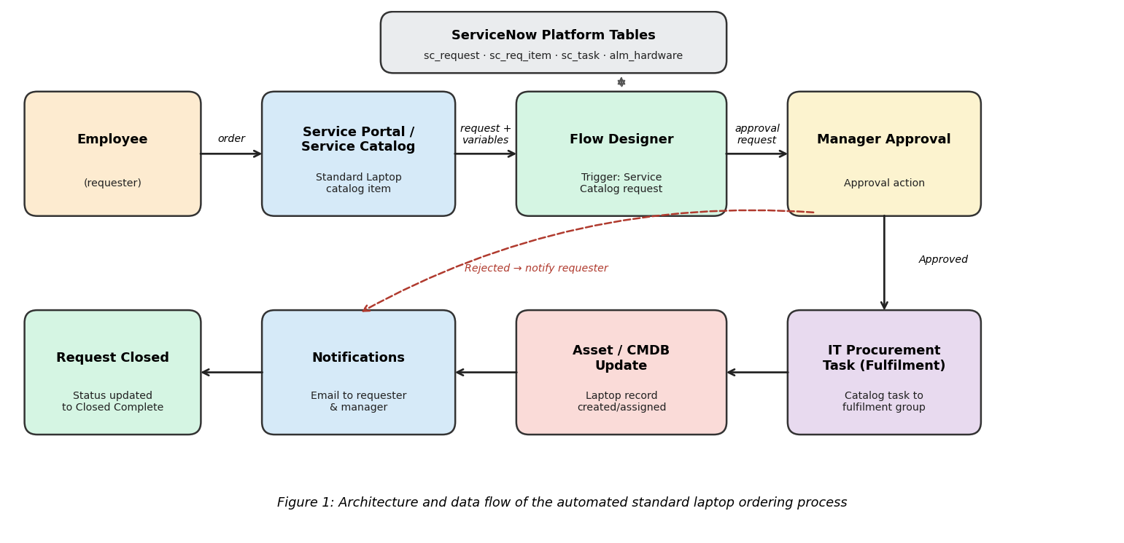
Data Flow Description:
- The employee opens the Service Portal and submits the Standard Laptop catalog item with the required variables (model, justification, etc.).
- Submitting the item creates a request and requested item record, which triggers the Flow Designer flow.
- The flow sends an approval request to the employee's manager.
- If approved, the flow creates a catalog task for the IT procurement (fulfilment) group; if rejected, the requester is notified and the request is closed.
- After fulfilment, the laptop is recorded in the asset/CMDB tables and assigned to the employee.
- Email notifications are sent to the requester and manager, and the request is marked Closed Complete.

